1. About the organization
2. Name, Location, Date of Culture Plunge, website link (if applicable)

The name of the organization is the National Stuttering Association (NSA), and the event happened in the Arts and Letters Building at SDSU on March 9th, 2020.

1. Contact information (i.e., website, email, and name of contact person if applicable)

The National Stuttering Association’s website is:

<https://westutter.org/find-nsa-meeting>-near/california/

Professor Diana Carson informed all of us of the event, and helped conduct it.

1. A 1-2 paragraph description of what you did during your time at the place or event, and the types of disabilities that were represented at the event.

The event was a panel of the leaders and members of the San Diego Chapter of the NSA; where they shared their experiences of growing up with and living with Stuttering. It was held in a classroom at SDSU, and we were listening to them speak and we were invited to ask them questions about their lives afterwards.

1. Reflection
2. What were your initial biases and stigmas you had before participating in your disability culture plunge activity? How did this experience change your thinking?

I had met people who stutter before; so prior to this event I didn’t really have any stigmas or biases towards people who stutter. But I hadn’t spoken with anyone with a stutter for a while, so the experience did remind me of how patient one needs to be when listening to them.

1. Explain how this experience relates to the social model of disability and/or the medical model.

In relation to the social model of disability, most of the challenges that people with stutters face on a daily basis are due to other people either not taking them seriously or not being patient enough to hear what they have to say. In addition, many over the phone services we take for granted are really set up to handle the speaking patterns of someone with this disability; typically, this seems to be a consequence of the designer’s being unwilling to fix potential issues or even consider that those issues might occur. In other words, the only thing ‘disabling’ them are things that we set up that don’t accommodate them.

1. Name at least 2 other concepts learned in this course and explain how they apply to your Disability Culture Plunge experience?

Regarding ableism, the speakers of the panel spoke at length about how the expectations of strangers could cause them anguish and make them feel as though they don’t belong. Whether they intended it or not, those expectations take an ableistic view as how everyone ought to speak and be heard. Further, they’ve fallen prey to the kind of tokenism and infantilization that people with disabilities experience. In some people’s minds they’re overcoming of stuttering is inspiration porn. Even in cases when that disability is invisible.

1. What accommodations or assistive technologies were used or were not used that you think could have been used to foster inclusion and access?

There weren’t really any “assistive technologies” at this event, it was like any ther panel. The first thing we really need to accommodate people who stutter is just to hear them out and be patient while we do. In other words, they need the first thing that people with disabilities need from all of us; understanding.

1. How might you see yourself including and contributing to the lives of people with disabilities now and in the future? And how might people with disabilities contribute to your life now and in the future?

I would try and contribute to their lives by befriending them, not excluding them, and by considering how my actions could affect them; negatively or otherwise. And, I suppose, people with disabilities could do the same for me.

1. Provide an example of your time in GS420 that altered your perspectives on disability culture and connect that with your disability culture plunge experience.

I didn’t really appreciate the degree to which disability culture is really a cuture of it’s own before taking this class. I interpreted the phrase with a little hyperbole when I first heard it, and this event (along with some of the speakers we’ve had in class) made me realize that disability culture exists. Listening to the panel speakers use very specific words to describe themselves, others, the way they speak, and their personal challenges helped me draw that conclusion. Language (in some sense) is culture, and having your own ways of talking about the world is apart of that.

1. 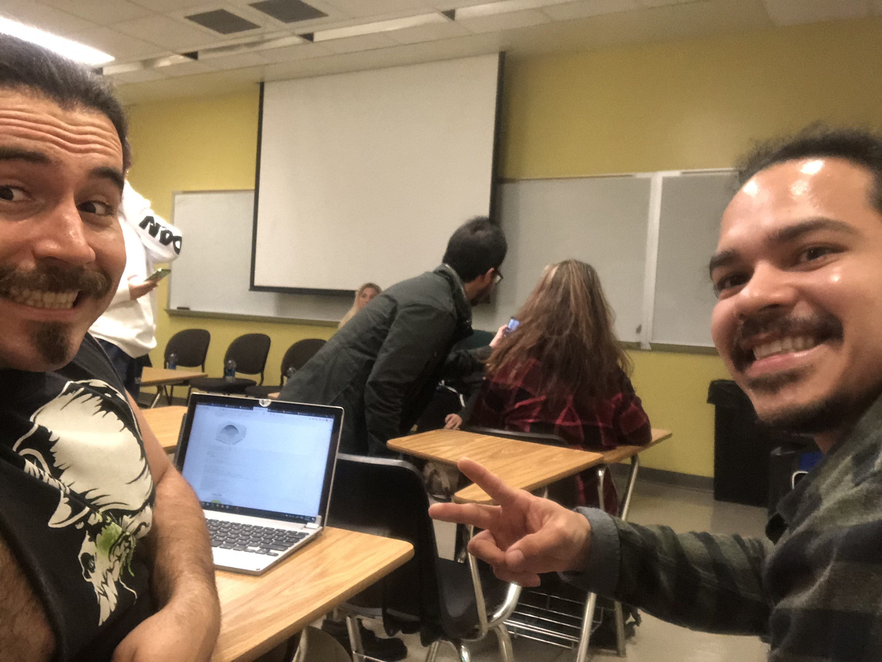Photos

